TOPIC 5 – Javadoc Documentation in NetBeans
- Documentation is where we put every detailed functional information for the read to learn and guidelines for the user. In programming we used documentation to document our program for easier to understand and for future purposes. Documentation is also written to support any activity. Javadoc is a tool that NetBeans uses for documenting java. Javadoc documentations are being generated to HTML form. Under Javadoc we have a “doc comment”, the doc comment is where we place the description, function, explanation for the block or lines of codes.
- Documentation generator made by Sun Microsystems for the Java dialect (now claimed by Oracle Corporation) for creating API documentation in HTML arrange from Java source code. Javadoc does not influence execution in Java as all remarks are evacuated at accumulation time.

Sample of doc comment

JavadocComment
- it is the place we locate the general portrayal, label marks with information’s.
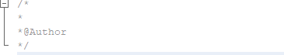

Block Comment
- this remark we can discover the depiction for the class and others.
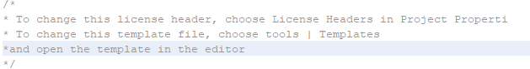

Inline comment- ignores everything to the end of the line
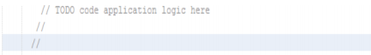

Generate Javadoc documentation-
- creates a Javadoc to the Javadoc organizer in your catalog at that point opens the documentation in the assigned program.
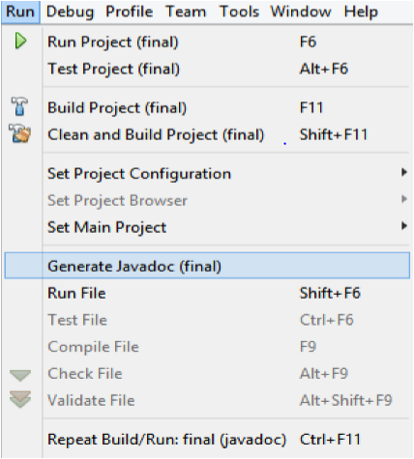

Auto generate comments in the file
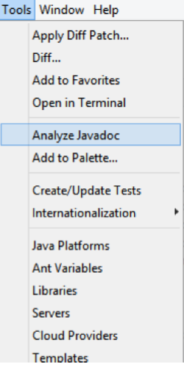
Step 1:

Click on tools in the navbar and select “Analyze Javadoc”

Step 2: Then check all the files
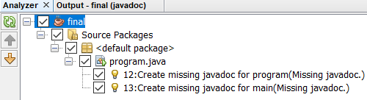

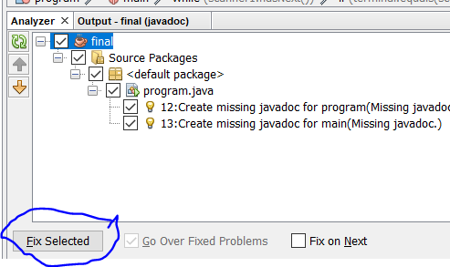
Step 3: Click on Fix selected to apply the changes

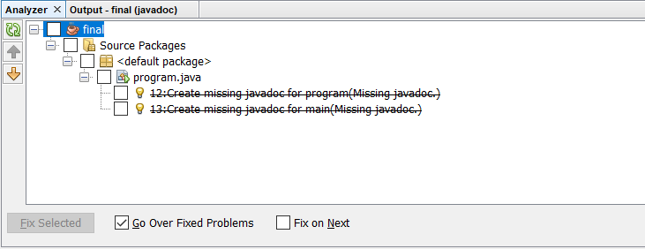

References:
Javadoc Comment, (N.D) Retrieved from https://stackoverflow.com/questions/4468669/how-to-generate-javadoc-html-files-in-eclipse
Java Documentation, (N.D) Retrieved from https://www.tutorialspoint.com/java/java_documentation.htm
How to generate Javadoc HTML files (N.D) Retrieved from https://stackoverflow.com/questions/4468669/how-to-generate-javadoc-html-files-in-eclipse

